WSDA Minimum Amounts of Seed to Submit for Testing

WSDA Seed Program offers a full complement of purity and viability testing services based on both AOSA, SCST, OECD and ISTA seed testing rules. There are purity results available for Canada and Canadian Grading. Digital imaging [photos] is available for most services provided.
Fees for testing are available online WAC 16-303.

How do I prepare a sample?

Samples are submitted in secured/sealed bags or trifold envelopes. Each sample must be properly identified with the crop kind, tests requested, identification (lot or reference number), and any treatment used must be identified with the active ingredient or trade name. To avoid spillage in transport, place the sample bag inside a Ziploc or plastic bag. Samples for moisture testing must be submitted in a sealed Ziploc bag to avoid moisture exchange. Avoid a manual sample check-in fee by using our XT-sample check-in form to ensure we get all the information needed to proceed with your testing.

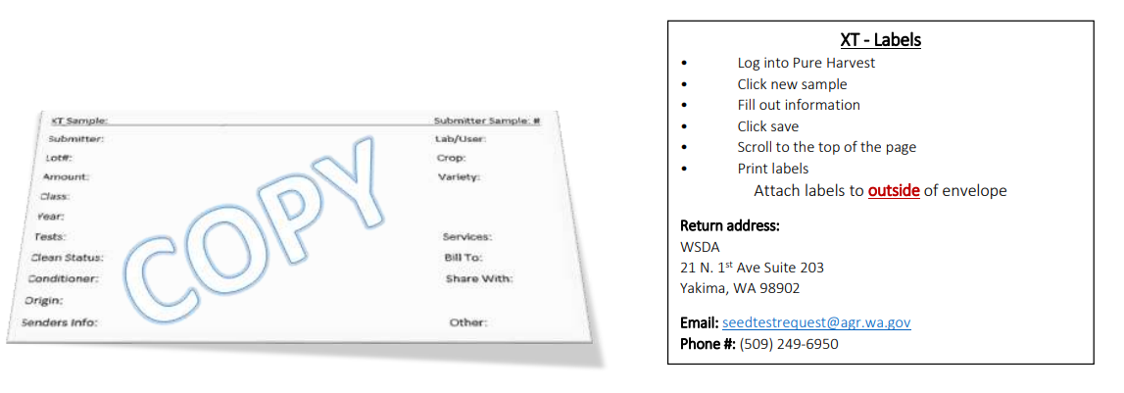

How much seed should be submitted?

For a complete set of common tests (purity, noxious, germ), the following are guidelines for common seeds.
Please call us if you have any questions or need more specific information.

Amounts to submit for Germ or TZ only analysis:
submit half the amount for Purity / Crop exam

Crop | Amounts to submit for Purity / Crop exam
A
Alfalfa (Medicago sativa) | 200 grams
Alkaligrass (Puccinellia spp.) | 50 grams
Asparagus (Asparagus officianalis) | 800 grams
Arugula (Eruca vesicaria subsp. sativa) | 50 grams
B
Barley (Hordeum vulgare) | 5 lbs.
Balsamroot (Balsamorhiza spp.) | 300 grams
Beans (Phaseolus vulgaris) | 3 lbs.
Bean, Lima (Phaseolus lunatus) | 3 lbs.
Beets, field, sugar (Beta vulgaris L. subsp. vulgaris) | 600 grams
Beets/ Swiss chard (Beta vulgaris L. subsp. vulgaris) | 600 grams
Bentgrass or Redtop (Agrostis spp.) | 25 grams
Bermudagrass (Cynodon dactylon) | 50 grams
Biscuitroot (Lomatium spp.) | 800 grams
Bitterbrush, Antelope (Purshia tridentata) | 200 grams
Blanket-flower (Gaillardia aristata) | 150 grams
Bluegrass, Alpine (Poa alpina) | 100 grams
Bluegrass, Canada, rough (Poa compressa) | 100 grams
Bluegrass, Kentucky (Poa pratensis) | 100 grams
Bluegrass, Rough (Poa trivialis) | 100 grams
Bluegrass, Alkali, big, Canby, Nevada, Pine, Sandberg (Poa secunda) | 100 grams*
Bluestem, Big (Andropogon gerardi) | 100 grams
Bluestem, Sand (Andropogon hallii) | 100 grams
Brome, Field (Bromus arvensis) | 200 grams
Brome, Smooth (Bromus inermis) | 200 grams
Brome, Meadow (Bromus biebersteinii) | 200 grams
Brome, Mountain- California, sweet (Bromus carinatus var. carinatus) | 400 grams
Buckwheat, grain (Fagopyrum esculentum) | 800 grams
Buckwheat, snow, sulfur, native types (Eriogonum spp.) | 75 grams
Burnett, small (Sanguisorba minor) | 400 grams
Burnett, prairie (Sanguisorba annua) | 200 grams
Broccoli (Brassica oleracea L. var. botrytis L.) | 200 grams
Brussel sprout (Brassica oleracea) | 200 grams
Brassica spp. | 200 grams
C
Cabbage (Brassica oleracea) | 200 grams
Camelina (Camelina spp.) | 50 grams
Canarygrass, reed (Phalaris arundinacea) | 50 grams
Canarygrass (Phalaris canariensis) | 300 grams
Cantaloupe (Cucumis melo) | 800 grams
Canola (Brassica napus var. napus) | 200 grams
Carrot (Daucus carota) | 50 grams
Catchfly (Silene spp.) | 25 grams
Cauliflower (Brassica oleracea L. var. botrytis L.) | 200 grams
Celery (Apium graveolens L. var. dulce) | 25 grams
Chard, Swiss (Beta vulgaris L. subsp. vulgaris) | 800 grams
Chickpea (Cicer arietinum) | 3 lbs.
Chives (Allium schoenoprasum) | 100 grams
Clover- Crimson, red (Trifolium incarnatum, Trifolium pratense) | 150 grams
Clover, White (Trifolium repens) | 75 grams
Coneflower (Ratibida spp.) | 200 grams
Coneflower, Purple (Echinacea purpurea) | 200 grams
Coriander (Coriandrum sativum) | 500 grams
Corn (Zea mays) | 2 lbs.
Cranberry (Vaccinium macrocarpon) | 50 grams
Cucumber (Cucumis sativus) | 800 grams
D
Daisy (Leucanthemum spp.) | 50 grams
Daisy, Ox-eye (Leucanthemum vulgare) | 50 grams
Dill (Anethum graveolens) | 100 grams
Dropseed (Sporobolus spp.) | 50 grams
E
Eggplant (Solanum melongena) | 150 grams
F
Fernleaf Biscuitroot (Lomatium dissectum) | 800 grams
Fescue, Tall (Festuca arundinacea) | 150 grams
Fescue, Meadow (Festuca pratensis) | 150 grams
Fescue, California (Festuca californica) | 150 grams
Fescue, all others (Festuca spp.) | 75 grams
Flax (Linum spp.) | 200 grams
Fleabane (Erigeron spp.) | 25 Grams
G
Grama, Side-oats (Bouteloua curtipendula) | 500 grams
H
Hairgrass (Deschampsia spp.) | 100 grams
Hairgrass, Slender (Deschampsia elongata) | 100 grams
Hairgrass, Tufted (Deschampsia cespitosa) | 50 grams
Hemp (Cannabis sativa) | 800 grams
J
Junegrass (Koeleria spp.) | 50 grams
K
Kale (Brassica oleracea var. viridis) | 200 grams
Kochia (Bassia scoparia) | 50 grams
Kohlrabi (Brassica oleracea) | 200 grams
Kiwi (Actinidia spp.) | 50 grams
L
Leek (Allium porrum) | 100 grams
Lentil (Lens culinaris) | 2 lbs.
Lettuce (Lactuca sativa) | 50 grams
Lovegrass (Eragrostis spp.) | 50 grams
M
Milkvetch (Astragalus spp.) | 150 grams
Millets (Panicum spp.) | 250 grams
Millets, Proso (Panicum miliaceum) | 250 grams
Mustard, White or Yellow (Sinapis alba) | 200 grams
N
Needle and Thread (Hesperostipa comata) | 200 grams
Needlegrass, Green (Nassella viridula) | 150 grams
Needlegrass, Thurber (Achnatherum thurberianum) | 150 grams
O
Oats (Avena sativa) | 3 lbs.
Onion (Allium cepa) | 100 grams
Orchardgrass (Dactylis glomerata) | 100 grams
P
Peas (Pisum sativum) | 3 lbs.
Penstemon (Penstemon spp.) | 200 Grams
Pepper (Capsicum spp.) | 3/4 envelope
Prairieclover, Blue Mountain (Dalea ornate) | 200 grams
Prairieclover (Dalea spp.) | 200 grams
Q
R
Radish (Raphanus sativus) | 400 grams
Rapeseed (Brassica napus) | 200 grams
Rescuegrass (Bromus catharticus) | 300 grams
Ricegrass, Indian (Achnatherum hymenoides) | 150 grams
Rutabaga (Brassica napus) | 100 grams
Ryegrass (Lolium spp.) | 200 grams
Ryegrass, Perennial (Lolium perenne) | 200 grams
S
Safflower (Carthamus tinctorius) | 800 grams
Sagebrush (Artemisia spp.) | 25 grams
Sainfoin (Onobrychis viciifolia) | 800 grams
Saltbush (Atriplex spp.) | 50 grams
Soybean (Glycine max) | 3 lbs.
Spinach (Spinacia oleracea) | 800 grams
Squash (Cucubita pepo) | 1000 grams
Squirreltail (Elymus spp.) | 200 grams
Strawberry (Fragaria spp.) | 100 grams
Sundangrass (Sorghum bicolor drummondii) | 800 grams
Sunflower (Helianthus annuus) | 800 grams
Sweetclover (Melilotus spp.) | 75 grams
T
Teff (Eragrostis tef) | 50 grams
Timothy (Phleum pratense) | 100 grams
Tomato (Solanum lycopersicum) | 100 grams
Trefoil, Birdsfoot (Lotus corniculatus) | 100 grams
Turnip (Brassica rapa) | 200 grams
U
V
Velvetgrass (Holcus lanatus) | 50 grams
W
Watermelon (Citrullus lanatus) | 1000 grams
Wheat (Triticum aestivum) | 5 lbs.
Wheatgrass, Crested (Agropyron cristatum) | 200 grams
Wheatgrass, Siberian (Agropyron fragile subsp. sibiricum) | 200 grams
Wheatgrass, Bluebunch (Pseudoroegneria spicata) | 1 envelope
Wheatgrass, Slender (Elymus trachycaulus) | 1 envelope
Wheatgrass, Thickspike (Elymus lanceolatus) | 1 envelope
Wheatgrass, Western (Pascopyrum smithii) | 1 envelope
Wheatgrass, Intermediate (Thinopyrum intermedium) | 1 envelope
Wheatgrass, Pubescent (Thinopyrum intermedium) | 1 envelope
Wheatgrass, Tall (Thinopyrum ponticum) | 1 envelope
Wildryes (Elymus spp.) | 3/4 envelope
X
Y
Yarrow (Achillea millefolium) | 1/4 envelope
Z
*Chaffy or field run seed send 200 grams

