Statewide Knotweed

Control Program

2016 Progress Report

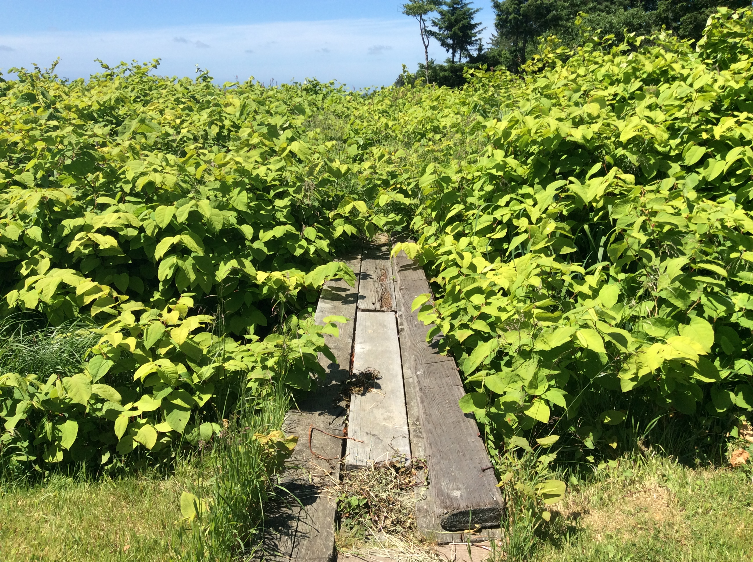

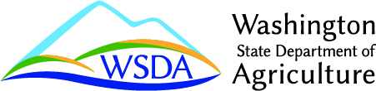

For more information or additional copies of this report, please contact:

Washington State Department of Agriculture
Pest Program
P.O. Box 42560
Olympia, WA 98504-2560
(360) 902-2070

WSDA Web site: http://agr.wa.gov

AGR PUB 809-534 (R/4/17)

Do you need this publication in an alternate format? Contact the WSDA Receptionist at
(360) 902-1976 or TTY Relay (800) 833-6388.

Cover Photo: knotweed infestation overtaking a walking path in Pacific County, Washington (Pacific County Noxious Weed Control Board).

WSDA has made every effort to ensure accuracy in compiling data and maps for this report. However, because much of the information comes from outside sources, WSDA cannot guarantee that it is without errors or omissions.

Table of Contents

Executive Summary…………………………………………………………………………..iiv
Introduction 1
The Problem 2
The Plants 5
WSDA Knotweed Control Program 7
Project Selection 8
Budget 9
Results 10
Outlook 10

Appendix A 12

Appendix B ……………………………………………...……………………………………14

Executive Summary

The Washington State Department of Agriculture (WSDA) Knotweed Control Program is a key component of the intergovernmental effort to protect and restore watersheds in Washington State. Knotweed includes four closely related noxious weeds that aggressively invade high value habitats and displace native vegetation. This program provides funding, coordination, and other resources to cooperators that conduct invasive knotweed control projects. The program works with tribal governments, local governments, non-governmental organizations, and state agencies. The program supports green jobs, benefiting the environment and economy of Washington.

WSDA works with groups throughout Washington to identify knotweed infestations, develop control projects, and secure grant funding. In order to minimize duplication of effort by program cooperators, WSDA fulfills state-level environmental review requirements, coordinates Federal Clean Water Act permit compliance, provides public notification, produces education materials and publishes required notices.

WSDA has received approximately $6.5 million for knotweed control since 2004. State funding allows program cooperators to secure additional resources that require state-origin matching funds. For the 2015-2017 biennium the WSDA Knotweed Control Program budget is $938,854, which allows for the support of project activities in watersheds of 20 counties.

For the 2015-2017 biennium cooperators submitted to WSDA, 28 proposals requesting a total of almost $1.3 million. WSDA furnished support to 24 of these projects and one biological control development project, providing a total of $624,000 for agreements and contracts. In 2016, over 250 solid acres of knotweed were treated with integrated pest management techniques, and project work occurred in nearly 750 river miles. These projects assisted more than 3,000 landowners.

WSDA will continue to support knotweed control as program funding allows. Eliminating projects would impact the habitat and restoration efforts of salmon bearing streams. In contrast, knotweed projects that have received stable funding have shown a vast decrease in knotweed presence.

Introduction

This is a progress report for the Washington State Department of Agriculture’s Statewide Knotweed Control Program. This report describes the program framework, survey methods, treatment methods, project selection process, budget for the 2015-2017 biennium, and results for calendar year 2016.

The results are divided into a programmatic summary to describe the general activity level of program cooperators, and monitoring results that describe the changes at infested sites. Three program measures are used to describe the activity level of program cooperators.
- Solid Acres Treated = A measure of how many acres a dispersed population would occupy if all knotweed plants were grouped together.
- River Miles = Total amount of river miles within project area(s) receiving any survey, treatment, and /or monitoring activities. River miles are measured once down the middle, not both shorelines.
- Landowners Assisted = Number of landowners receiving survey, treatment, and /or monitoring activities within project area(s).

Analyzing the total acreage surveyed, monitored, or treated by program cooperators on an annual basis is a reasonable method to describe the amount of area affected by knotweed, but it is not a precise way to detect the change that occurs within infested sites following herbicide applications. Due to this challenge, WSDA used monitoring plots to detect the within-site change of knotweed populations following annual treatment activities implemented by program cooperators. The trend in data showed a significant decrease in knotweed following a series of annual treatments.

Across the state, the knotweed populations that persist in project areas have fewer stems per acre and the knotweed that is present exhibits reduced stem height, stem diameter, and overall vigor. Many native plants, including tree and shrub species, have reestablished in areas where they had previously been displaced.

After treatment, follow-up activities at project sites are important. When a site is left untreated, small amounts of living knotweed can return to original infestation levels in as few as three seasons, placing the site back on a path towards a monoculture of knotweed and subjecting the project area to the negative consequences of knotweed invasion.

The Problem
The invasive knotweeds are non-native plants that have been introduced to Washington State without the factors that keep their populations under control in their native range. Knotweed alters riparian vegetation communities, disrupts nutrient cycling, negates riparian restoration efforts, negatively affects the recreational use of watercourses, and decreases property values. Knotweed has been reported in all 39 counties of Washington State. These plants are pioneer species that quickly colonize disturbed areas. Once knotweed becomes established, it is very difficult to remove, and single patches can persist for more than 100 years.

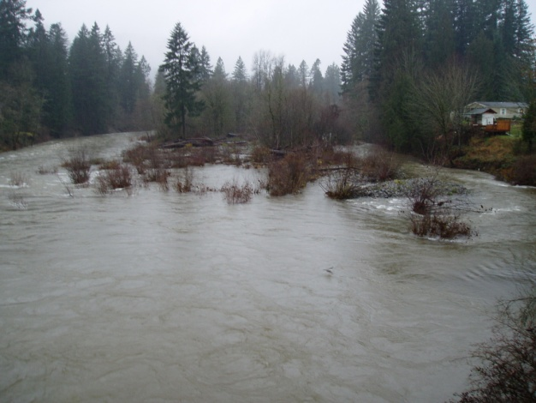
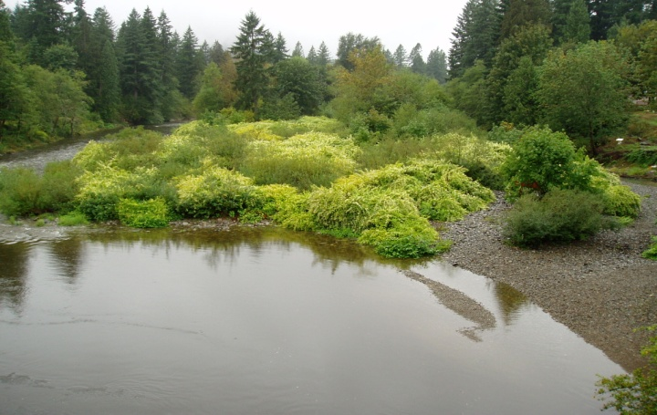
In the Pacific Northwest, knotweed spreads when roots and stems are moved by natural means or human activities. Human activities include moving soil that contains knotweed plant material, mowing or cutting knotweed, or discarding knotweed plant material in vulnerable habitats.
Figure 1. Gravel bar in the Washougal River during summer flow (left) and winter flow (right) levels.
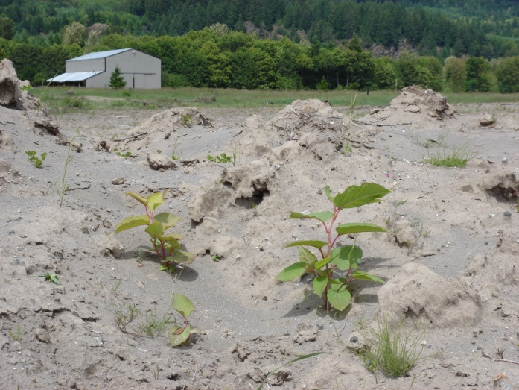
In river corridors, knotweed reproduces from fragments and seeds that travel downstream, affecting the gravel bars and riparian forests of entire river systems. Figure 1 shows natural flooding of a knotweed-infested gravel bar. This site served as a source for new infestations as knotweed stem and root fragments were transported downstream by the flowing water. Root and stem fragments as small as one inch can produce a new plant. As a result, one patch can be the source of many downstream populations.

Figure 2 shows knotweed sprouting from fragments deposited by floodwaters in the Cowlitz River valley. If left untreated, these small plants will form multi-stemmed patches. When these patches coalesce, they exclude all other vegetation. Figure 3 shows a knotweed-infested watershed in Pacific County. Knotweed had displaced most of the understory plants at this site and occupied any opening created by natural disturbance.
Figure 2. Knotweed plants sprouting from plant fragments deposited by flood water.
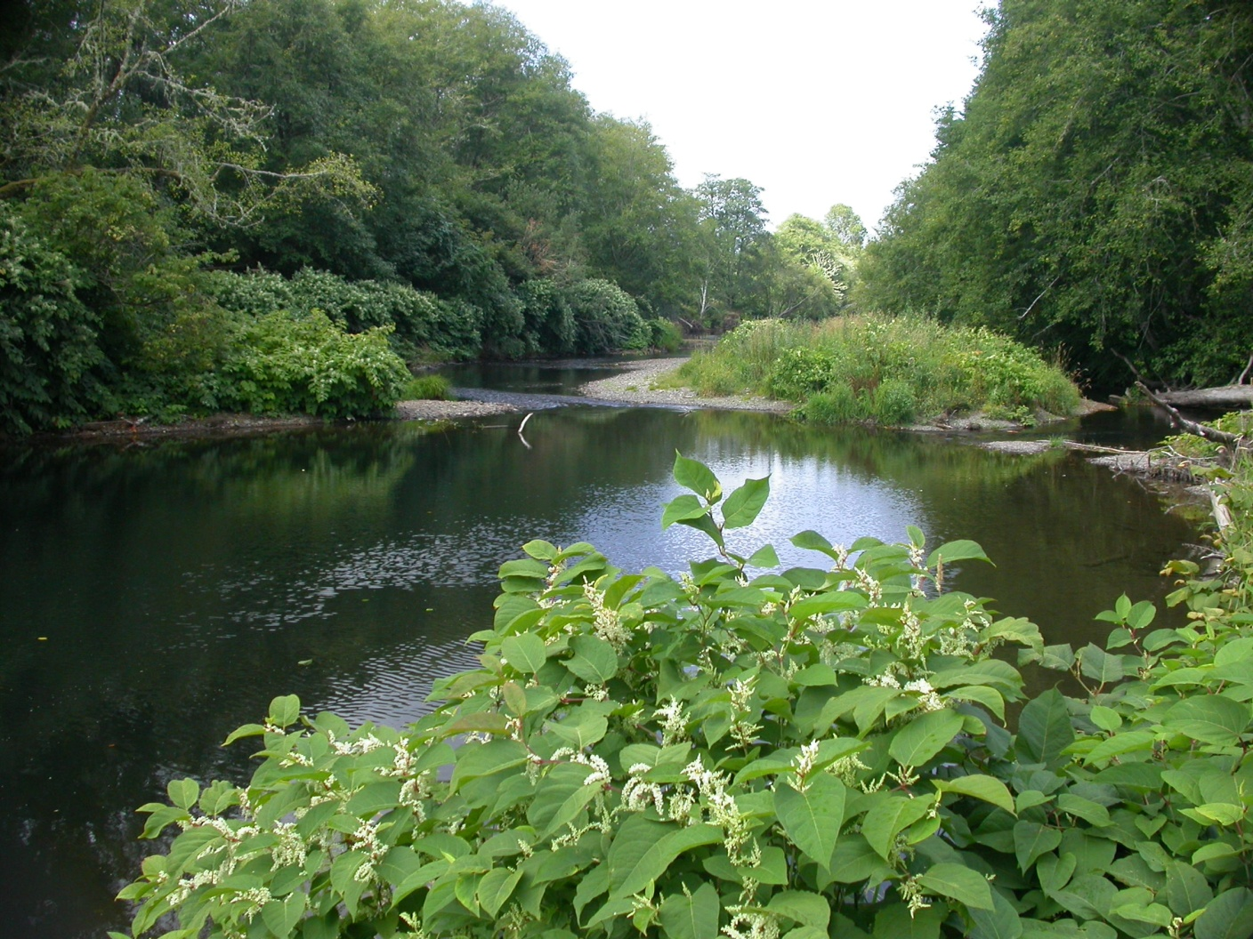
Figure 3. Watershed in Pacific County infested by Bohemian knotweed.
Riparian areas are transitional habitats located between terrestrial and aquatic ecosystems such as lakes or rivers. Riparian areas provide shade, nutrients, and large woody debris to both aquatic and terrestrial ecosystems. Over time, riparian areas that are occupied by early-successional native species such as alder, willow, and other shrubs, move toward a plant assemblage dominated by conifers. These functions take many decades to recover once impacted by any disturbance.

Substantial resources have been applied to the protection or restoration of riparian areas in Washington State for the benefit of fish, wildlife, and recreation. Many of these projects seek to reintroduce or protect riparian vegetation that is critical to self-sustaining ecological services of forests and streams. However, many of these projects are located in areas vulnerable to knotweed invasion. Knotweed infestations can ruin the sustainable benefits of these projects by out-competing the offspring of the native plantings and dominating the vegetation community in the long-term.

When sites are heavily infested by knotweed, there are fewer juvenile trees available to replace mature trees removed by natural disturbances such as wind, flood, or fire. Instead, the knotweed present in the understory fills any gaps that are created. Failure to control knotweed at these sites will result in a monoculture of knotweed that excludes beneficial riparian vegetation in the future.

The lack of juvenile tree species in knotweed-infested riparian forests could also result in a decrease in large trees available to fall into stream channels. These large pieces of wood, also known as large woody debris are important to the rivers and streams of the Pacific Northwest. Large woody debris creates pool habitats, retains spawning gravels, and provides cover for juvenile salmonids. The loss of large woody debris can disrupt natural processes, leading to a down-cutting of the stream bed, loss of side channel fish habitat, loss of pool habitat, decreased retention of spawning gravels, and decreased cover for juvenile salmonids and their prey. Depending on the time of year and salmon species, a decrease in the number of pieces and volume of large woody debris has been shown to decrease the number of salmon that utilize the section of stream lacking large woody debris. This could negatively impact efforts to restore salmon populations.

Knotweed can also have a negative effect on aquatic invertebrates that are the basis of the aquatic food chain by disrupting or altering the quality and timing of leaf litter inputs. This lowers the species diversity of invertebrates and negatively affects the organisms and processes that depend on them. Invertebrates are the primary food source of juvenile fish species.

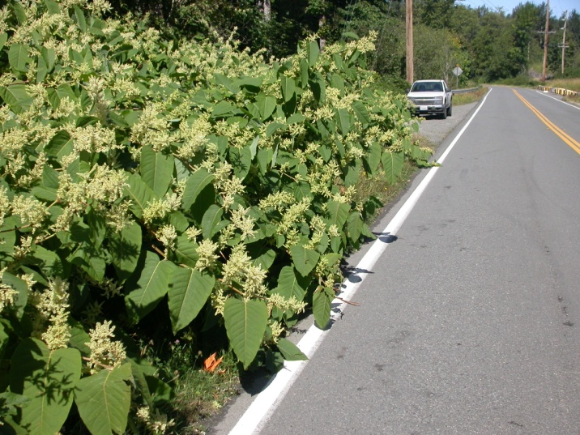
Knotweed often negatively affects residential property and transportation infrastructure (Figure 4). Along right-of-ways, knotweed can grow through materials used for roadways, causing the need for expensive repairs. Knotweed patches also pose potential sight-distance hazards to vehicle operators due to rapid growth, affecting public safety on roadways.
Figure 4. Negative impact of knotweed on transportation in King County.

Habitat modeling performed by WSDA indicates that knotweed currently occupies a small fraction of its potential habitat in Washington. However, there is evidence that knotweed populations outside of current project areas will continue to expand, and will eventually invade these suitable areas.

The Plants
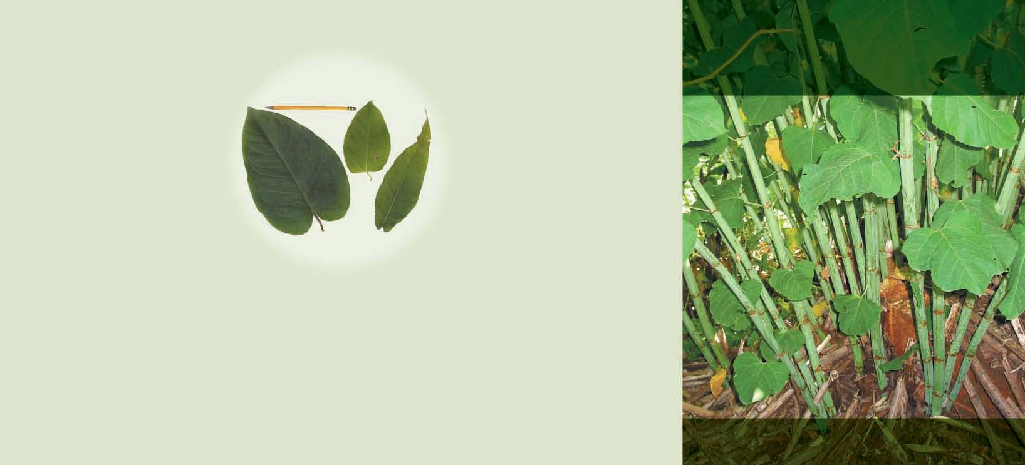
The invasive knotweed complex is comprised of four herbaceous perennial plant species from the buckwheat family (Polygonaceae) that are native to Asia. They are broadleaf plants that have green stems and reddish nodes (Figure 5). The plants were introduced to the United Kingdom and the United States as garden ornamentals in the early part of the 20th century. The four species are commonly referred to as Japanese, Giant, Bohemian, and Himalayan knotweed. All four species occupy similar habitats and cause similar negative impacts. They are collectively referred to as knotweed in this report. The four species are alternatively placed in either Polygonum or Fallopia genus.
Figure 5. The green, bamboo-like stems of invasive knotweed.
- Japanese knotweed (Polygonum cuspidatum Sieb. & Zucc.) The leaves of this plant are blunt at the base and sharply tapered at the tip (Figure 6). The stems of this plant usually grow to 7 feet tall. Stem diameters range from one-half to one inch.

- Giant knotweed (P. sachalinense Schmidt) This is the largest of the four invasive knotweed species. It has large heart shaped leaves (Figure 6), stems that can grow up to 12 feet tall, and stem diameters up to two inches.

- Bohemian knotweed (P. x bohemicum Chrtek & Chrtkova) This is the hybrid produced by giant and Japanese knotweed. Leaf shape, stem diameter, and stem heights are variable, but are usually within the range of the smaller Japanese knotweed and larger giant knotweed. It is the most common invasive knotweed species in Washington State.
Figure 6. Leaves of three species of knotweed. From left to right
are the leaves of giant, Japanese, and Himalayan knotweed.

- Himalayan knotweed (P. polystachyum Wall) has lance-shaped leaves that make it readily identifiable when compared to the other species (Figure 6). The stems of this plant usually reach one half inch in diameter, and four to five feet in height. It is most common in the coastal areas of southwest Washington.

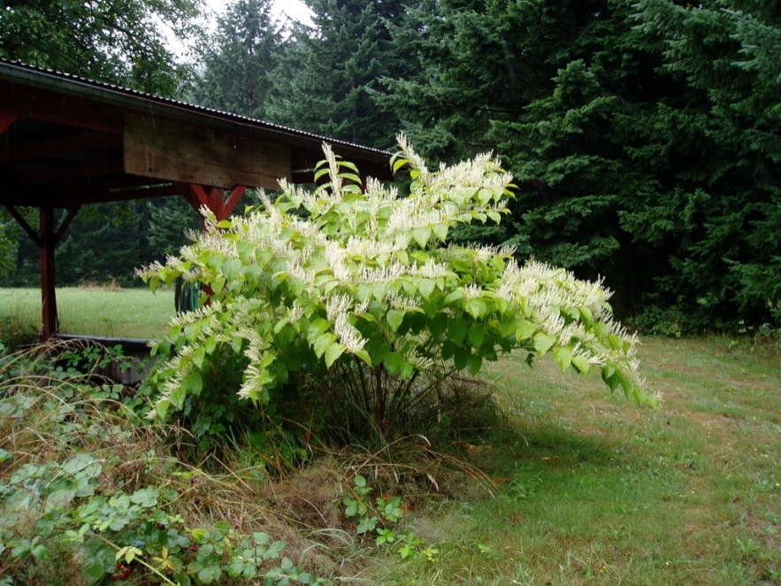
All four species are listed as Class B noxious weeds on the Washington State Noxious Weed List (WAC 16-750-011). Class B noxious weeds are designated for control in regions of Washington State where they are not yet widespread. In regions where Class B noxious weeds are abundant, mandatory control is decided at the county level. In addition, all four species are included in the Washington State noxious weed seed and plant quarantine list (WAC 16-752-610). Under this rule, it is illegal to transport, buy, sell, or trade any of the invasive knotweed species.
Figure 7. Flowering knotweed in Skamania County.

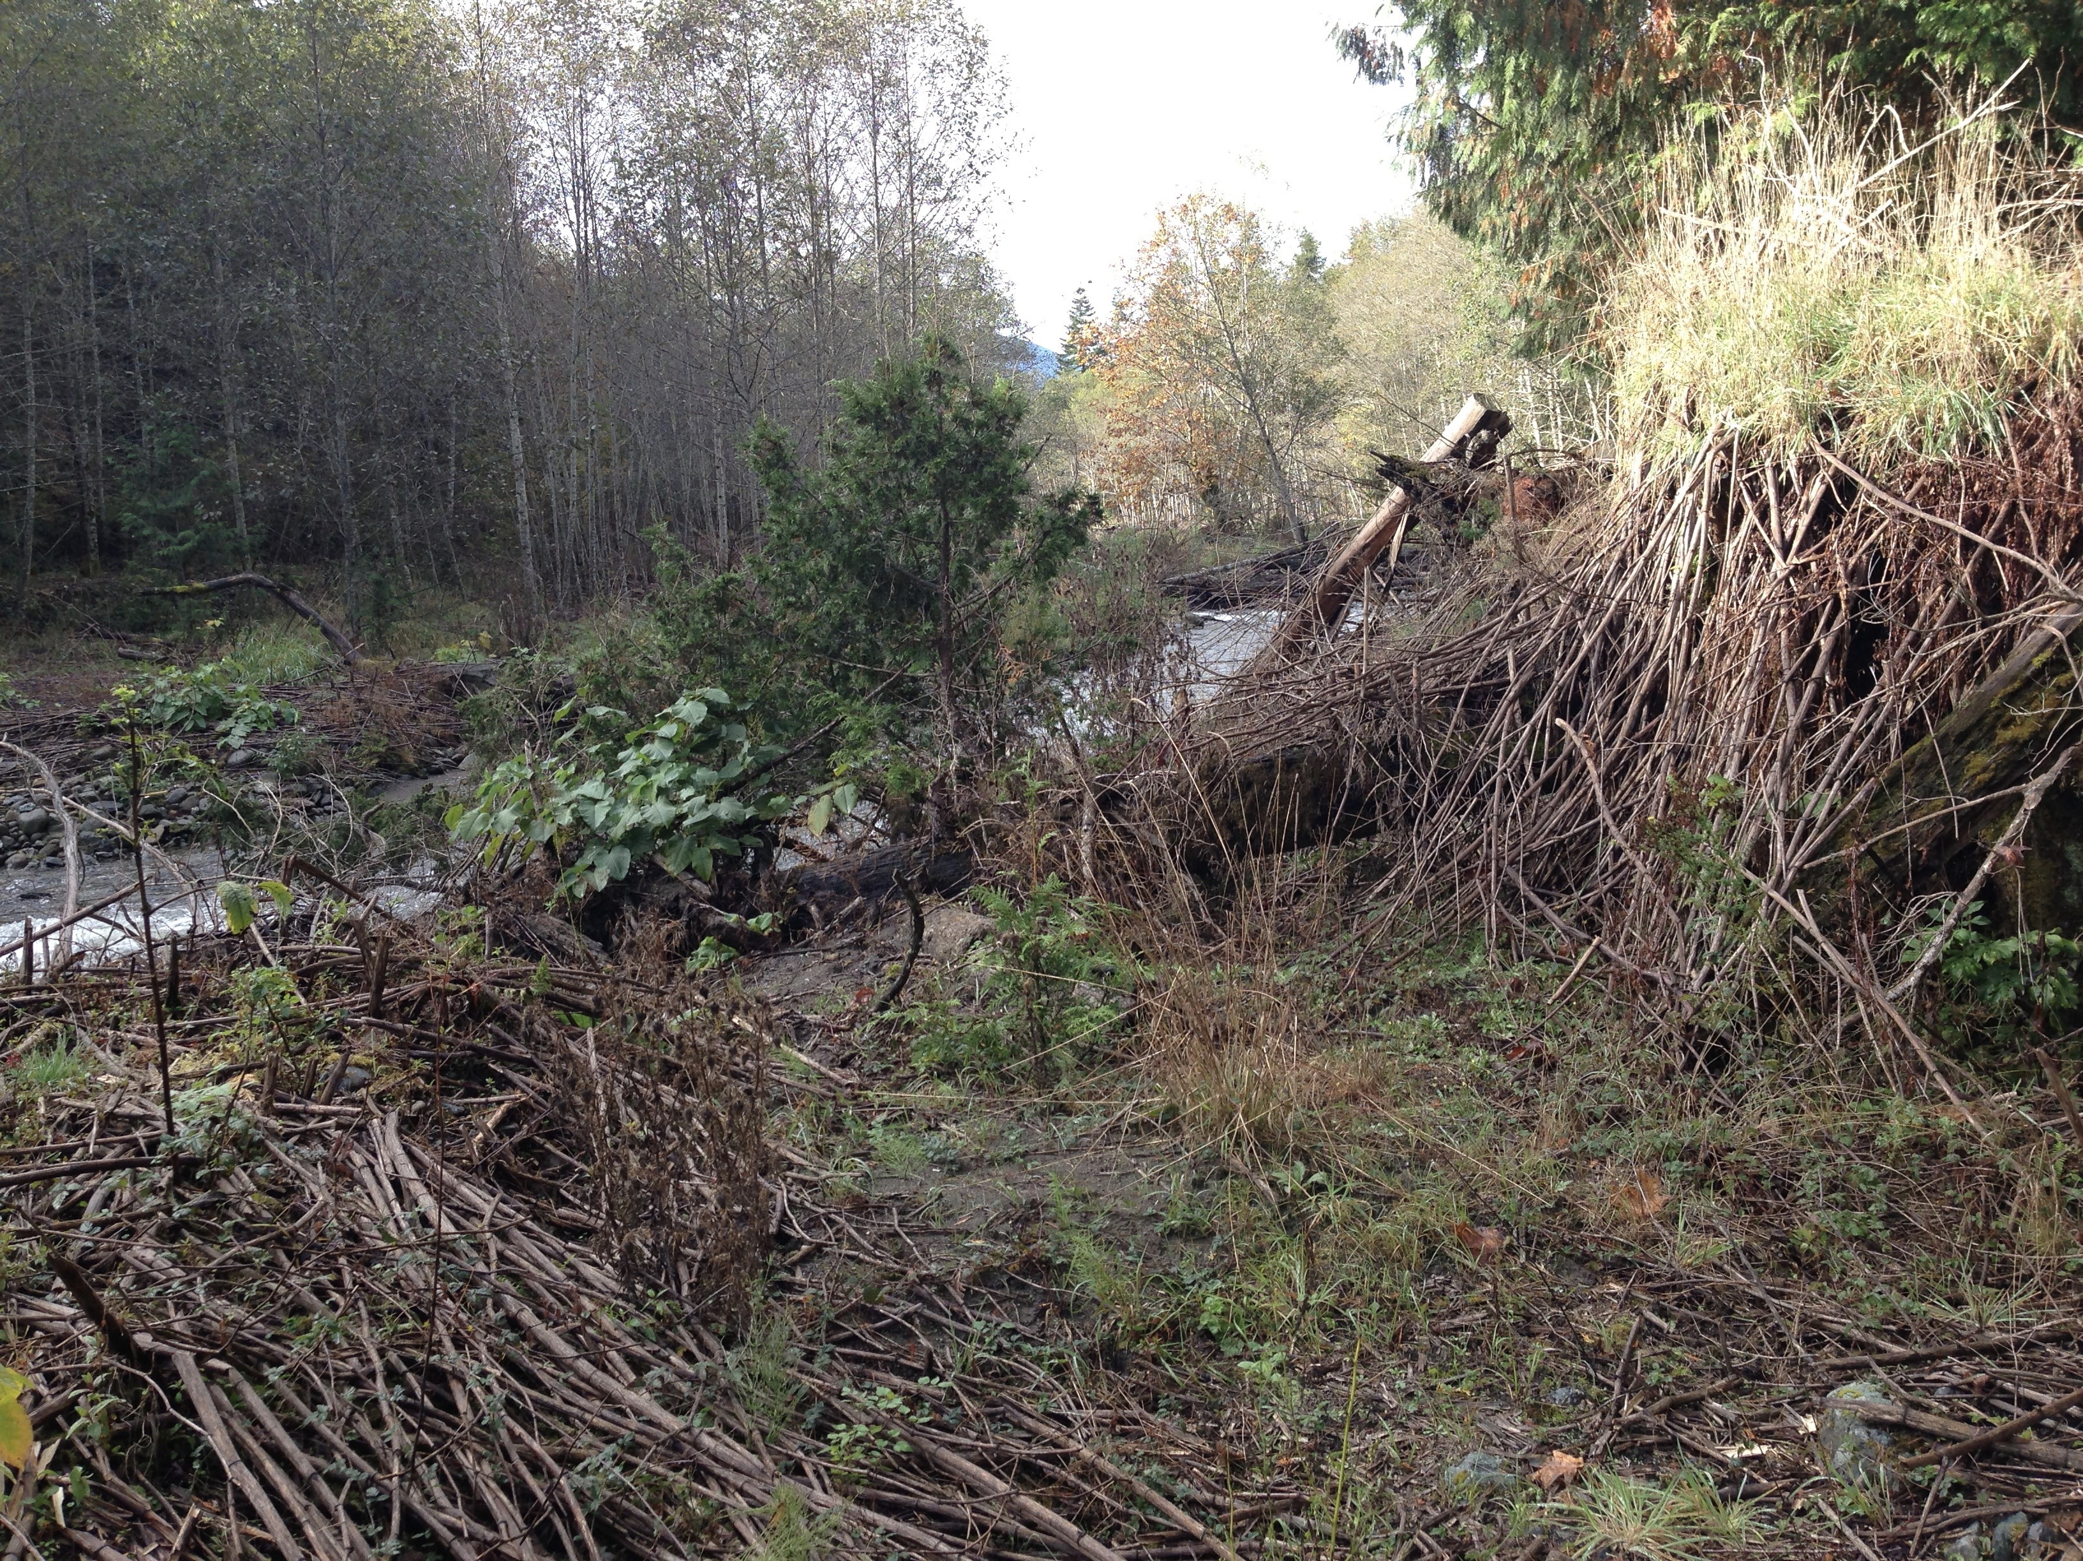
Invasive knotweeds have extensive underground rhizome and root systems. They thrive in moist soil or river cobble, in full or partial sunlight, and are most common along rivers, creeks, beaches, and disturbed areas.
Figure 8. Aerial stems of knotweed emerge within the dead shoots from the previous year on Grandy Creek in Skagit County.

The aerial stems of knotweed emerge in spring and reach full height by early summer. The plants flower in late summer or early fall (Figure 7), and the aerial shoots die after the first frost leaving living underground root systems. The dead shoots persist through the winter, and can remain standing for several years (Figure 8).

WSDA Knotweed Control Program

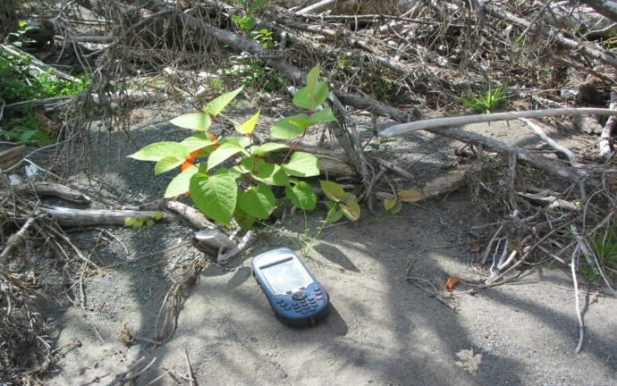
Since 2004, the Washington State Department of Agriculture has partnered with multiple organizations to locate and control knotweed in select watersheds across the state. Implementing annual field surveys and targeted herbicide applications has proven to be a very effective means of controlling knotweed. Program cooperators survey for knotweed by wading or boating streams and driving right-of-ways in each project area. The location of knotweed is documented, and this information is used to identify the ownership of affected parcels. Figure 9 shows the location of a knotweed plant being recorded in the Hoh River. Program cooperators provide educational materials and notification to each landowner prior to the performance of any control activities. Most landowners are familiar with the negative impacts of knotweed and welcome the assistance provided by program cooperators.
Figure 9. Recording the location of a knotweed plant in the Hoh River.
Treatment methods are selected based on site and infestation characteristics according to integrated pest management (IPM) principles. An important IPM consideration for the program is the treatment of all known knotweed populations in the selected river corridor, starting at the upstream source of the infestation and working in a downstream direction. This strategy helps to ensure that untreated knotweed plant material will not re-infest treatment sites as it moves downstream.

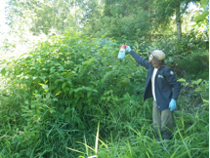
Treatments are conducted when the knotweed plants are actively growing. Figure 10 shows a crewmember making a targeted herbicide application to knotweed in Skagit County. Program cooperators apply formulations of the systemic herbicides imazapyr or glyphosate, alone or in combination. Foliar delivery of herbicide was the primary treatment method used by project cooperators in 2016. The use of herbicide has been proven to be the most effective treatment method.

Program cooperators use herbicides that are registered in Washington State for use in or near water. WSDA requires that all aquatic herbicide applications be made under the supervision of a licensed applicator. Funding to support the WSDA knotweed program helps to ensure that licensed and trained professionals make herbicide applications near water.
Figure 10. Crewmember treating knotweed in
Skagit County.

Project Selection
The organizations that implement knotweed control projects in Washington State are growing in both numbers and type. Many cooperative weed management groups have formed to combat invasive knotweed, bringing together landowners, land management agencies, tribal governments, county noxious weed control boards, fisheries enhancement groups, conservation districts, and other conservation organizations and citizen groups. With the increase in organizations involved in knotweed control comes an increase in need for funding to support cross-jurisdictional projects on the scale of whole river systems.

For the 2015-2017 biennium, WSDA prioritized and supported projects that:
- protected previous accomplishments;
- cost-effectively controlled knotweed populations; and
- protected large, ecologically important areas.

In combination with these recommendations, WSDA used the project area's current infestation level, health of riparian areas, and the extent that requested funds would be used to leverage additional funding to rank proposals and develop a list of projects that would be supported.

For the 2015-2017 biennium, 28 proposals requesting a total of $1,285,595 were submitted. WSDA furnished support to 24 of these projects and one biological control development project, allocating a total of $634,200 for agreements and contracts. Figure 11 shows the counties with supported projects.

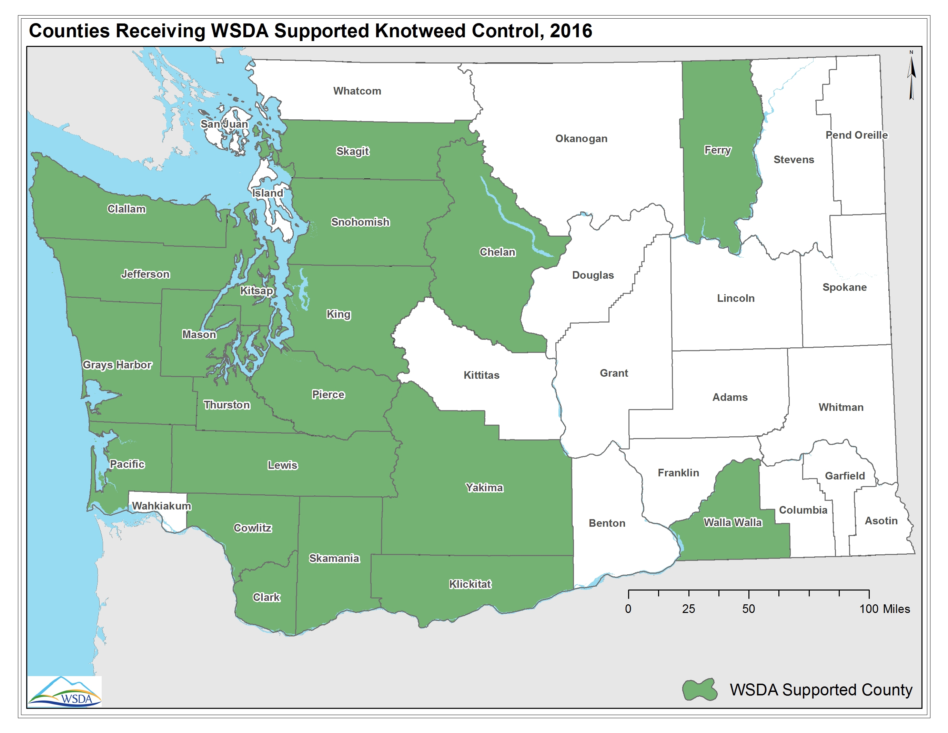
Figure 11. Map depicting the counties where WSDA supports knotweed control projects.

Budget
The Washington State Department of Agriculture has administered a knotweed control program since 2004 when the Legislature provided an appropriation of $500,000 per year for a pilot program in southwest Washington. In total, WSDA has received around $6.5 million to control knotweed since 2004. This funding has been critical for the ability of our program cooperators to secure additional resources by providing them with state-origin matching funds.

For the 2015-2017 biennium, the WSDA knotweed control program budget is $938,854 (Table 1). WSDA coordination expenses include agency administration costs, permitting and environmental compliance, salaries and benefits for coordination, legal and clerical support, equipment costs, printing, and other goods and services.

Table 1. Estimated budget activity for the 2015-2017 biennium.
Activity |  |  | Expenditure
Purchased services |  |  | $634,200
 | 10,000 Years Institute | $35,000
 | Chelan County | $42,000
 | Clallam/Jefferson County | $35,000
 | Clark County | $40,000
 | Cowlitz County | $32,000
 | Ferry County | $4,700
 | Hood Canal Salmon Enhancement Group | $60,000
 | King Conservation District | $15,000
 | Kooskooskie Commons | $7,500
 | Lewis County | $20,000
 | Mason County | $15,000
 | Oregon State University | $40,000
 | Pacific County | $50,000
 | Pierce Conservation District | $40,000
 | Skagit County | $21,000
 | Skagit Fisheries Enhancement Group | $40,000
 | Skamania/Klickitat County | $40,000
 | Snohomish County | $45,000
 | Thurston County | $30,000
 | Yakima County | $12,000
 | Yakama Nation | $5,000
 | Washington State University | $5,000
Herbicide/Equipment |  |  | $50,000
Coordination |  |  | $254,654
 | Total Biennial Expenditures |  | $938,854

Results
In addition to a biological control development project with Oregon State University and Washington State University (see Appendix A), in 2016 WSDA provided resources to the entities listed in Table 2 below. These cooperators implemented knotweed control projects in watersheds of 20 counties.

WSDA uses three metrics to track the progress of each project. Solid Acres Treated is a measure of how many acres a dispersed population would occupy if all knotweed plants were grouped together. River Miles and Landowners Assisted includes any survey, treatment, and/or monitoring activities. In cases where our projects are focused on the treatment of upland knotweed populations in order to prevent the infestation of the shorelines of rivers, the river miles measured does not apply. Table 2 shows a summary of the work performed by program cooperators in 2016.

Table 2. Results by program cooperator for the 2016 control season.
Organization | Solid Acres Treated | River Miles | Landowners Assisted
10,000 Years Institute | 0.07 | 27 | 18
Chelan County | 1.28 | 63.7 | 855
Clallam/Jefferson County* | 40.7 | 41.9 | 19
Clark County | 3.7 | 17.3 | 493
Cowlitz County | 8.2 | 77.86 | 87
Ferry County | 0.26 | 1 | 17
Hood Canal Salmon Enhancement Group | 1.62 | 21.59 | 258
King Conservation District | 5.73 | 4.7 | 7
Kooskooskie Commons | 5.5 | 109 | 32
Lewis County | 3.5 | 36 | 129
Mason County | 3 | 2.3 | 49
Pacific County | 23.96 | 63.75 | 332
Pierce Conservation District | 9.5 | 22 | 74
Skagit County | 18.58 | 14 | 26
Skagit Fisheries Enhancement Group | 0.33 | 55 | 44
Skamania/Klickitat County* | 0.75 | 60.3 | 43
Snohomish County | 115 | 28.12 | 46
Thurston County | 3.97 | 25 | 167
Yakima County/Yakama Nation* | 4.9 | 73 | 318
Total | 250.55 | 743.52 | 3014
*These groups worked in a shared project area with a combined crew

Outlook

WSDA continues to work with program cooperators to develop sustainable knotweed control strategies. As in the past, state resources were utilized to leverage additional funding. Combining funding and resources from multiple sources allows program cooperators to implement projects on the scale of entire watersheds. In 2017, program cooperators will continue to place emphasis on landowner participation and education. This provides landowners and land managers with the knowledge and experience to be the long-term stewards of their respective project areas.

WSDA will continue to support the development of biological control methods for knotweed. Typically, biocontrol agents do not reduce the populations of invasive plants as much as other control techniques. However, if self-sustaining populations of biocontrol agents can be developed in the future, this may constitute a cost-effective and self-sustaining suppression strategy for sites heavily infested by knotweed.

If left untreated, there is evidence that the small amount of live knotweed present at treatment sites can return to the original infestation level in as little as three seasons, eventually surpassing the infestation level present prior to any investments in knotweed control. This would result in the loss of progress toward long-term knotweed control, increased future control costs, degradation of environmental quality, and the alteration of the sustainable ecological services of invaded sites.

WSDA will continue to support knotweed control as program funding allows. The funding outlook in 2017 appears stable. In the past, funding reductions have led to the abandonment of projects and reduced support for ongoing initiatives. Eliminating projects would impact the habitat and restoration efforts of salmon bearing streams. In contrast, knotweed projects that have received stable funding have shown a vast decrease in knotweed presence.

Appendix A

Annual Progress Report
Knotweed Biological Control Program 2016

Submitted by Fritzi Grevstad, Oregon State University

Introduction

After extensive testing and review, the knotweed psyllid (Aphalara itadori) is in the final stages of federal permitting for release as a biological control agent for Japanese and giant knotweeds. In November of 2013, this insect, native to Japan, was approved by the Technical Advisory Group for Biological Control of Weeds (TAG) for release into North America. Since that time, the proposed biological control introduction has been under review by the USDA Animal and Plant Health Inspection Service (APHIS) and the the U.S. Fish and Wildlife Service.

Two biotypes of the psyllid are proposed as biocontrol agents. Colonies of both biotypes are maintained in the Oregon State University Quarantine facility in Corvallis, Oregon. The northern biotype from the Island of Hokkaido performs best against giant knotweed and some genotypes of hybrid knotweed. The southern biotype from the Island of Kyushu is most effective against Japanese knotweed and most genotypes of hybrids. Both are needed to control the varied knotweed species complex that is invasive in North America. The objectives proposed in this project represent the final steps to bring the knotweed biocontrol program into the implementation phase.

Progress by Objective for 2016

(1) Maintain colonies of the two biotypes of Aphalara itadori

Two separate colonies of the knotweed psyllid (north and south strains) were maintained throughout 2016 in the Oregon State University Quarantine Facility. This required growing a steady supply of potted knotweed plants to feed the psyllids. Both Japanese and giant knotweeds were collected periodically from the field sites in Oregon and Washington and were grown in pots in a greenhouse (separate from the quarantine). Fresh healthy plants are moved into the colony cages every two weeks or so and the dead or depleted plants are removed from the quarantine through the autoclave. Due to roof renovation in Richardson Hall, the quarantine and greenhouse cooling system was shut down during three different periods of a few days each. To keep the insect colonies from overheating, it was necessary to move them out of the greenhouse and into the laboratory section of the quarantine during these periods.

(2) Carry out additional tests and other requirements for obtaining release permits

In April of 2016, APHIS finally responded to the report on follow-up experiments that were provided in September of 2015. They provided a series of seven questions that were raised by the US Fish and Wildlife Service. Dr. Grevstad promptly provided a written response to these questions. In July, 2016, a conference call was requested by US Fish and Wildlife to further discuss the responses. Following this meeting, USFWS and APHIS both appeared satisfied and a Biological Assessment was completed by APHIS for the section 7 consultation. The Biological Assessment was sent out for review by the regional Fish and Wildlife offices and a response is expected soon.

(3) Preparations for release and monitoring

Field preparations were initiated in 2015 (see 2015 report). No further preparations for field releases were made in 2016, since the release permit has not yet been issued. Once issued, preparations for release and monitoring will commence right away. These will include final field site arrangements, setting up monitoring transects, rearing of insects and releases. This work is being planned with Jennifer Andreas, who will assist with carrying out and monitoring field releases in the State of Washington.

Appendix B
Olympic Knotweed Working Group
Leadership Award

Submitted by Cathy Lucero, Clallam County Weed Board Coordinator

Introduction

Partnerships are crucial to successfully prevent and control invasive species. The Olympic Knotweed Working Group (OKWG) is a loose-knit consortium of governments, tribes, non-profits and private landowners that sets the gold standard for cooperation, coordination and achievement.

Started by the Clallam County Noxious Weed Control Board (NWCB) in 2005 with the specific goal to eliminate invasive knotweed in riparian habitat within Clallam County, the OKWG has grown into a four county and beyond Cooperative Weed Management Area that includes multiple invasive plant targets. The Clallam County NWCB, as the de facto group leader, coordinates working group meetings, supports the work of other members, and publishes an annual report summarizing all project activity. The Working Group meetings are a forum for exchanging information and ideas, networking and pooling resources. Meeting discussions help identify future needs, data gaps, obstacles and solutions to problems. Area experts and other professionals present the latest research and data allowing licensed applicators to accrue required education credits with topics that best serve their needs while encouraging a higher professional standard.

Importantly, this OKWG collaboration yields impressive results on the ground. More than twenty entities across the four Peninsula counties, working on 29 different waterways encompassing over 200 miles of river, helped hundreds of landowners with their knotweed infestations in 2015 alone!

Leadership Award

In February of 2015, Cathy Lucero, the Clallam County Weed Board coordinator, traveled to Washington D.C to accept a leadership award from the National Invasive Species Council in recognition of her efforts to unite entities across the Olympic Peninsula battling the spread of invasive plant species, while protecting natural resources and native ecosystems. Department of the Interior Deputy Assistant Secretary Olivia Ferriter and Kevin Shea, administrator for Animal and Plant Health Inspection Services, USDA officiated at the awards ceremony that recognized nine individuals and organizations in three categories; Lifetime achievement, Leadership, Outreach and Education/Volunteerism, with either a terrestrial or aquatic component.

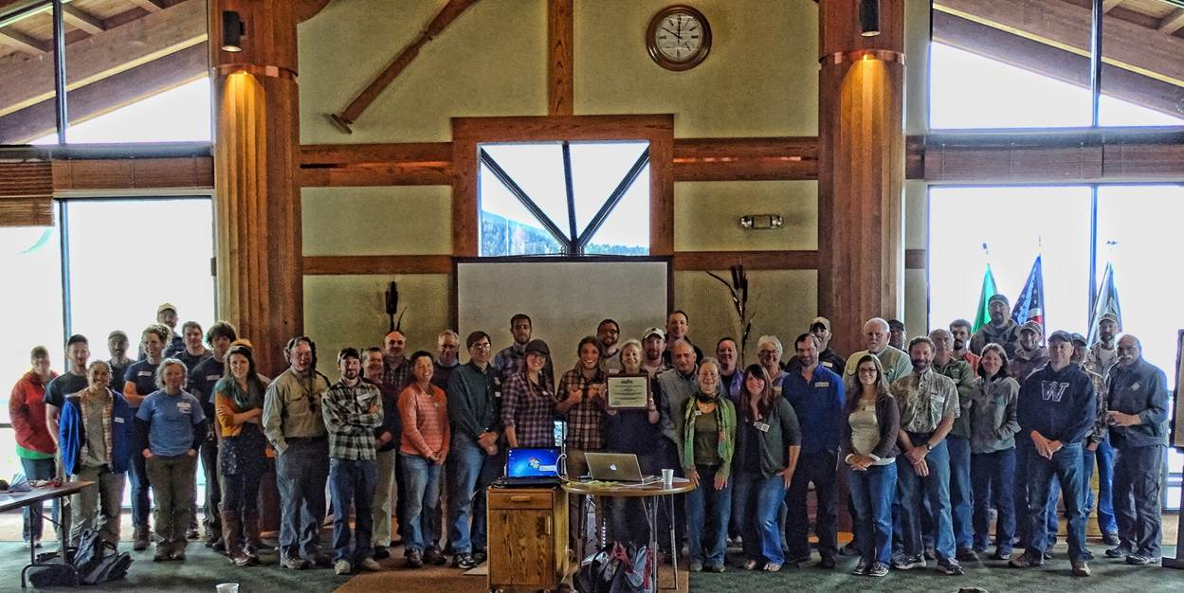

A group photo shows just some of the people involved in the combined OKWG effort. Cathy Lucero is shown (center) holding her leadership award during a break at the 2015 spring Olympic Invasives Working Group meeting hosted at the Jamestown S’Klallam Tribal campus.

